Two examples:

This one worked. Before screenshot below.

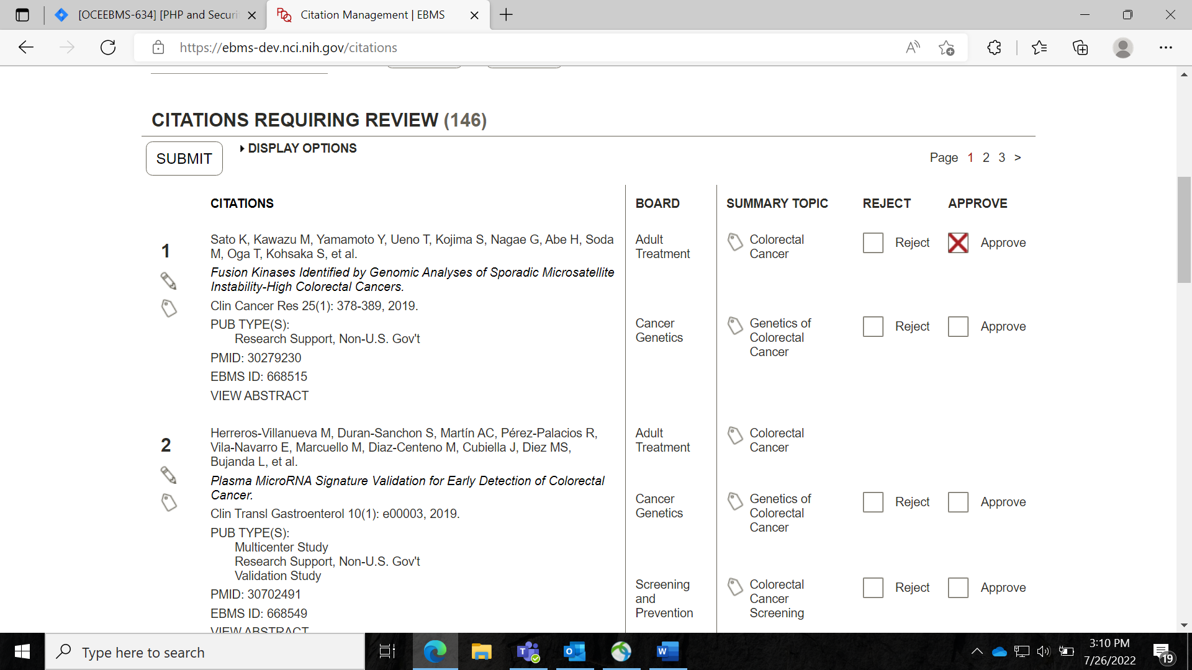

After screenshot below. Citations is still in queue.

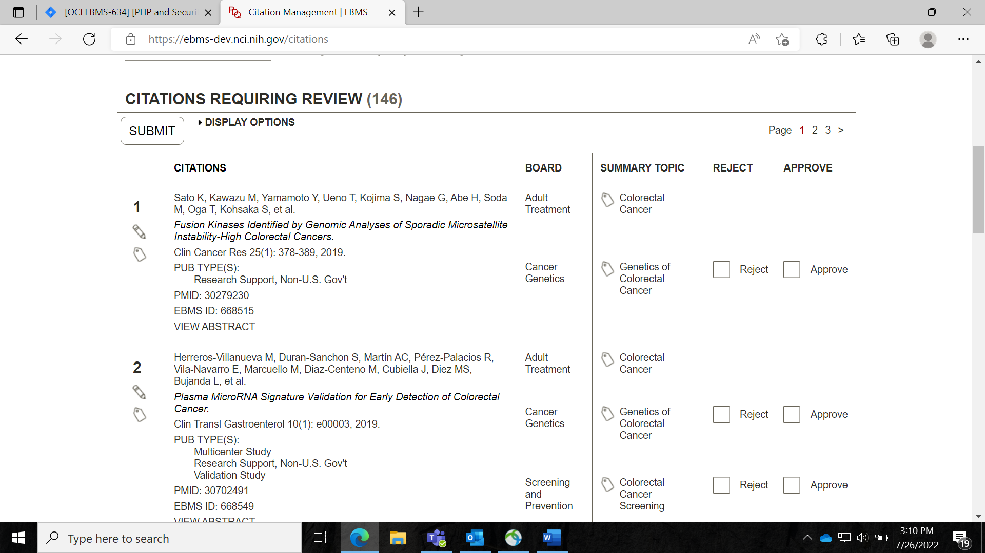

This one did not work. Before screenshot below.

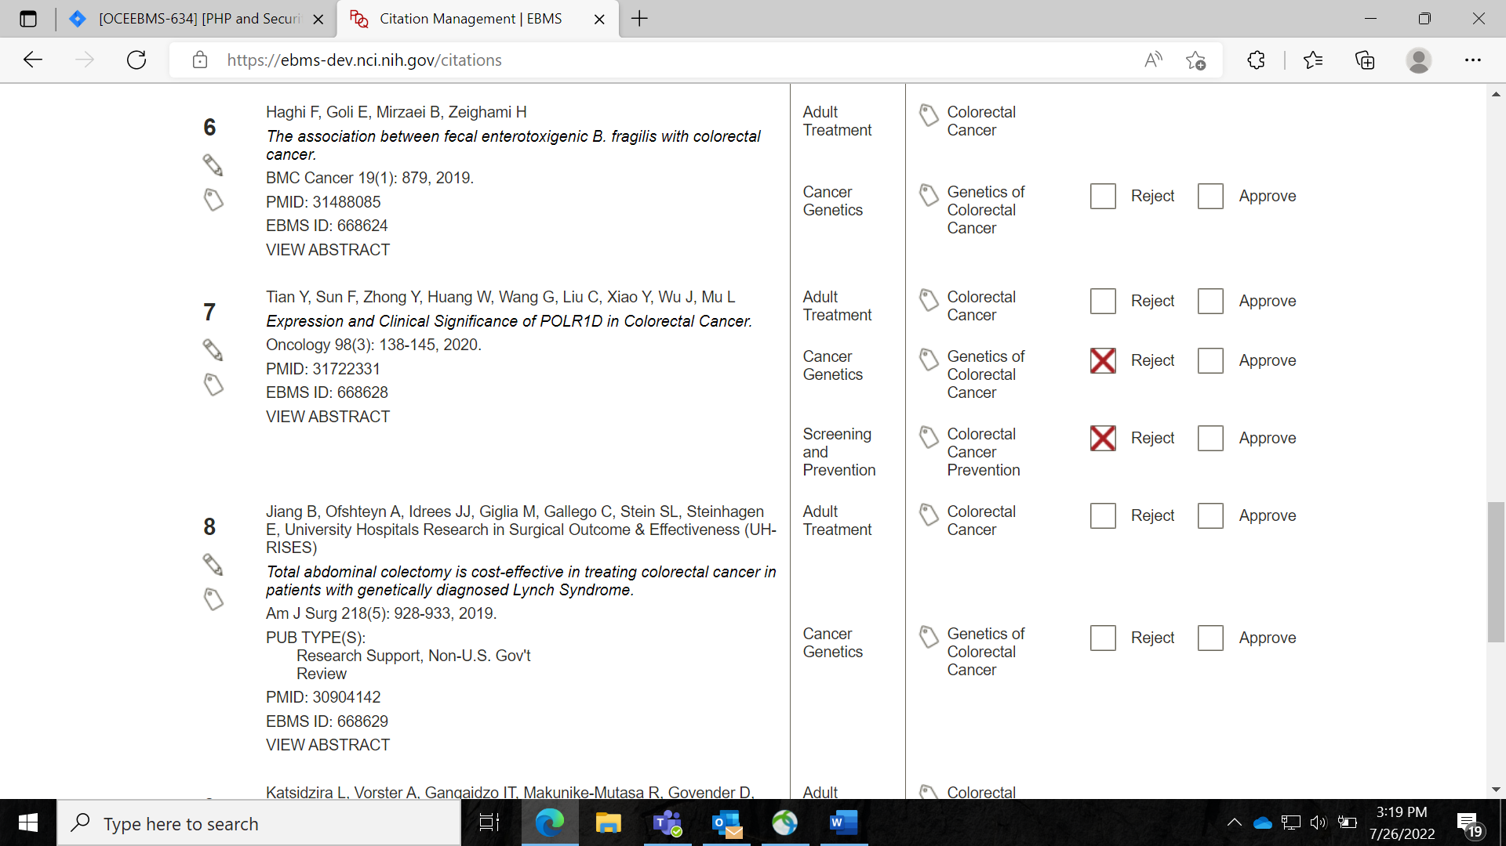

After screenshot below. The citation is no longer in the queue.

