Add option to search a range of review cycles on the search the database screen…

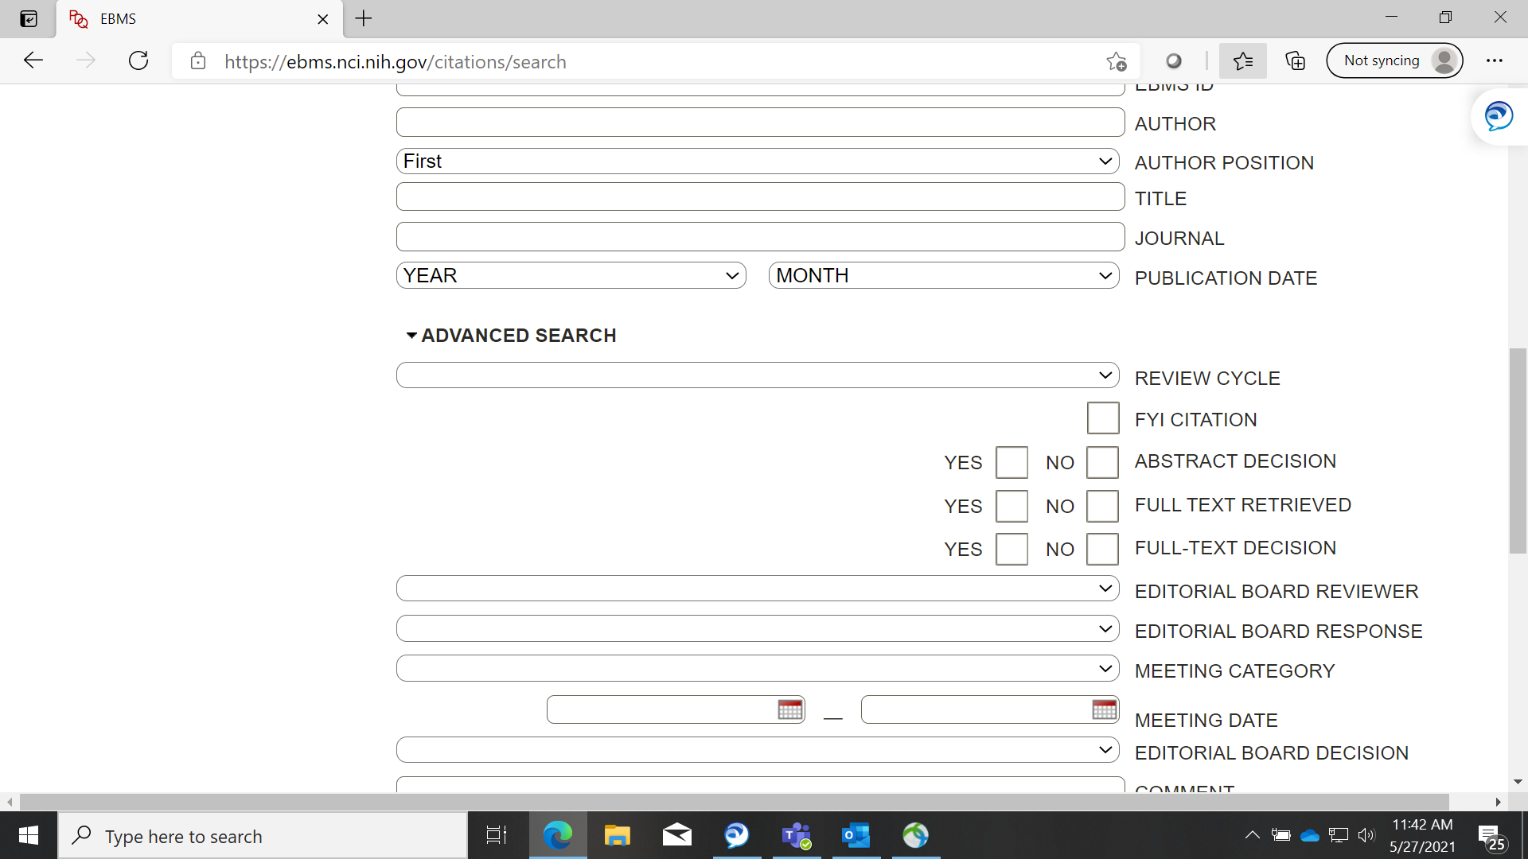

And on the citation management reports screen…

