Explanation of current problem with the NOT Journal Lists
5-18-2010
From the CMS staff web interface under Admin Tool there is a feature to Add New Journal Title. This allows us to add new titles that have been added to PubMed and to keep our list of titles up to date in the CMS.
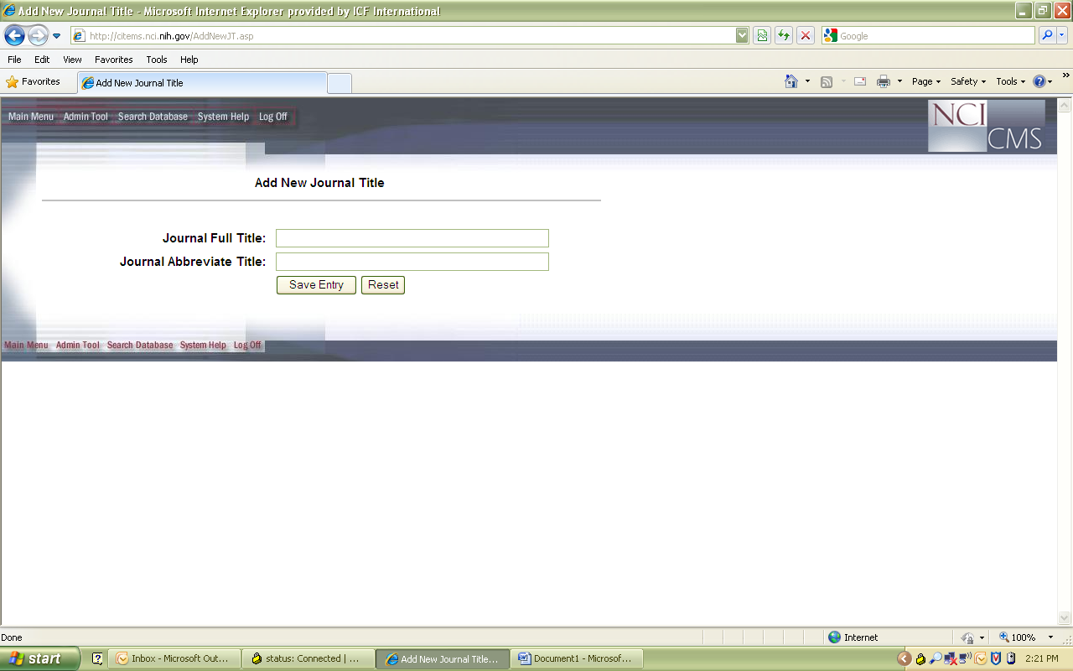
This feature seems to work because when we add a new title it appears in the complete journal title list we can view from the import utility’s Edit NOT List feature. The complete list appears on the left side under Journal List and then titles included in the NOT lists for each editorial board appear on the right side. In the screen shot below the Adult Not list is being displayed.
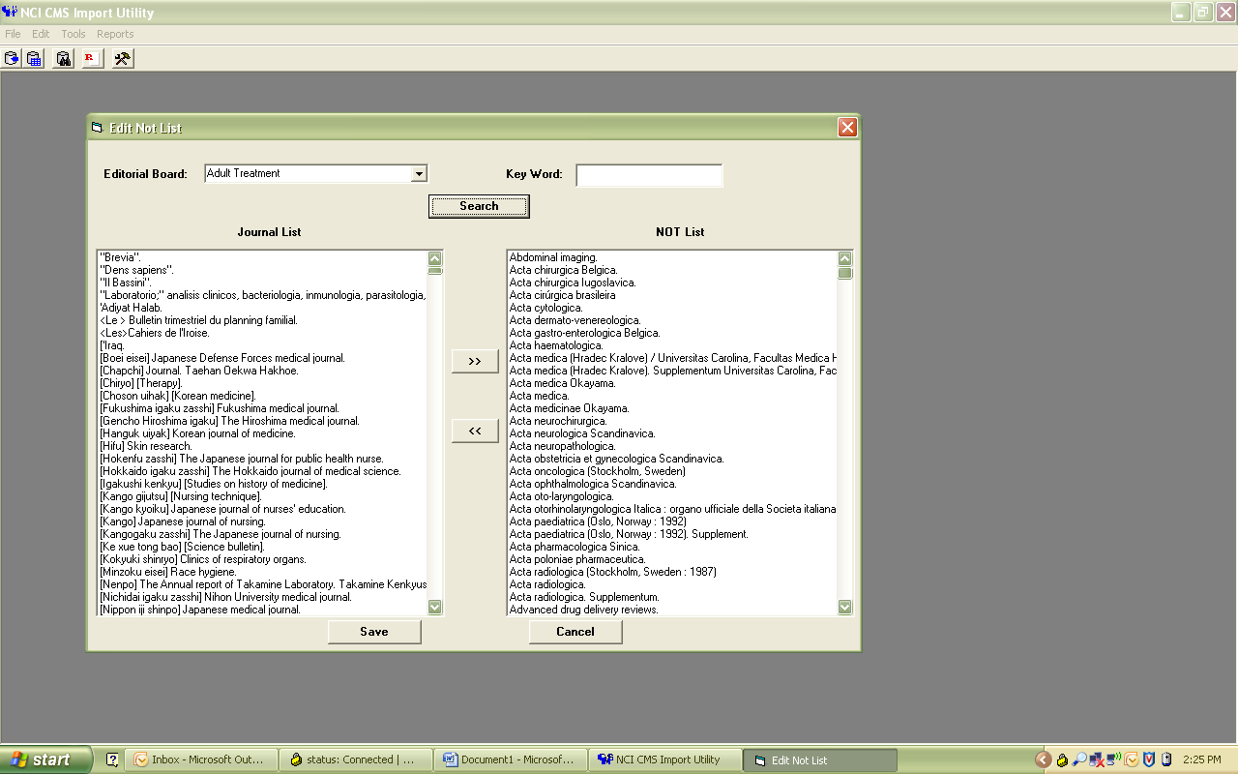
When Minaxi added the following two titles: Transfus Apher Sci and East Afr J Public Health; they appeared on the left side in the complete journal list. Then she used the arrow buttons in the middle to select these two titles and move them over to the right side to be included in the Adult NOT list. They then appeared in the list on the right side under the Adult NOT list. So the titles should have been successfully added.
From the Find Record search screen in the import utility there is an option that allows us to search for citations from journals that are on one of the editorial board NOT journal lists. When we select adult board, check the not list box and limit the search to March 2010 review cycle , we retrieve 14 citations, but the CMS Id 202026 for Transfus Apher Sci is not in the list. Minaxi added one more journal title—“stroke” to the NOT list at the same time when she added Transfus Apher Sci . This title was already listed in CMS and is included in the retrieved list of 14 citations (CMS ID 202009, second from the end of the list). The same is the case with East Afr J Public Health, which was not in CMS earlier and was added to journal list and then added to adult NOT journal list. Two citations from this journal CMS Id 201890 & 201891 also do not appear in the search for Adult NOT journals for March 2010 review cycle.
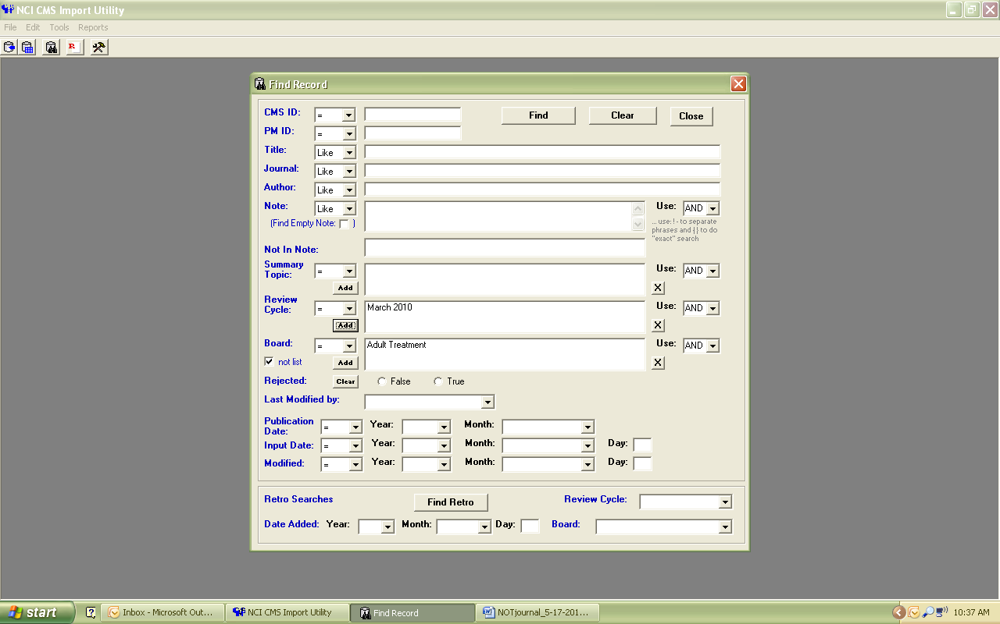
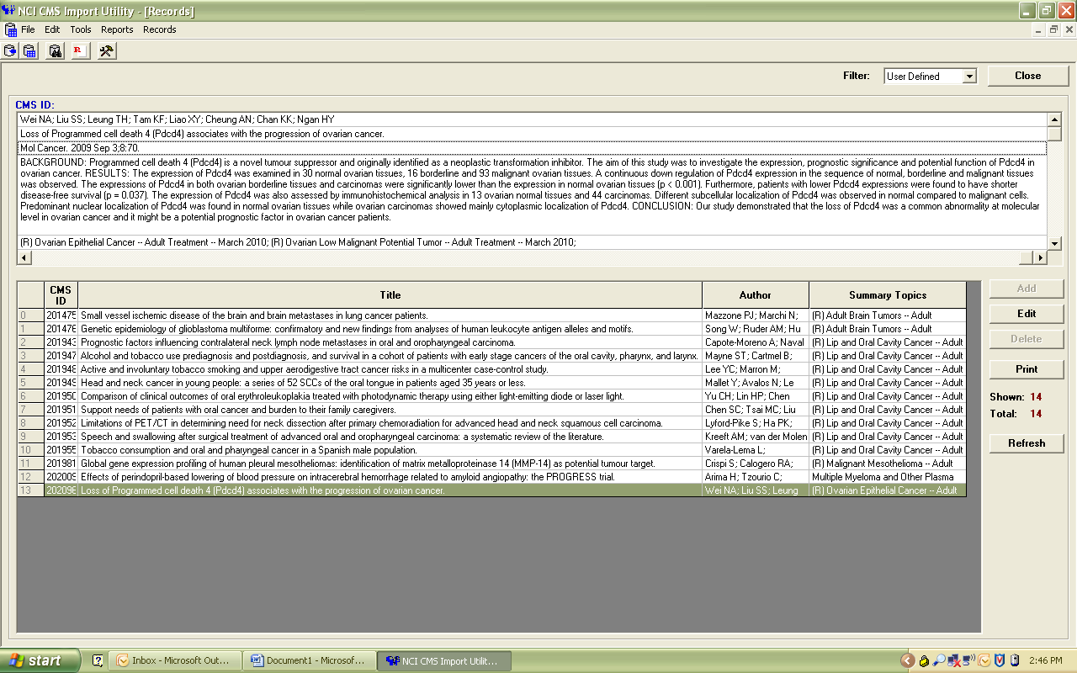
Each month we run a search to check for citations from journals listed in each of the editorial board NOT lists so that we can reject them for publication and further review. We need to be able to limit this search by review cycle and know that we are not missing citations from newly added journal titles.

