Citation Management System

Training Documentation

Introduction

Purpose of the Citation Management System

The Cancer Information Products and Systems (CIPS) of the National Cancer Institute (NCI) maintains the PDQ® (Physician Data Query) clinical trials database; a major section of this database is cancer information summaries on treatment of more than 80 adult and pediatric cancers, genetics and cancer, screening and prevention, and complementary and alternative medicine and cancer. These summaries are developed and/or maintained by five PDQ® editorial boards, which meet several times each year to review recently published literature and make recommendations about how current summaries should be changed or new summaries created to reflect the latest research as reported in the published literature.

Complex literature surveillance is required to ensure that relevant and timely published literature is identified for review by the editorial boards. Monthly searches of the medical literature are conducted in topics of interest to the editorial boards. These searches yield up to 1,500 candidate citations per month. The Citation Management System was designed to ensure that multiple levels of review of these candidate citations are thorough, accurate, and completed in a timely fashion, and that the status of candidate citations can be documented.

Literature Surveillance Process

Every month, literature searches are conducted for the PDQ® cancer information summaries, and the search results are entered into the Citation Management System Database. Citations entered into the database are assigned a review cycle that designates the month and year the citations were added to the database. Each citation is also assigned an editorial board and one or more summary topics. On the basis of the review cycle, editorial board, and summary topic assignment, a list of current citations ready for review is generated for each CIPS reviewer. Citations selected by the CIPS reviewers for full-text review are retrieved, photocopied, and discussed at the next literature surveillance committee meeting. The committee reviews the full text and decides whether the citation should be reviewed by selected editorial board members for specific summary topics.

After the literature surveillance committee selects citations for further editorial board member review, full-text copies of these citations are mailed with cover sheets to the appropriate editorial board member(s). Member responses are returned on the cover sheets and recorded in the database. An editorial board member may indicate that a citation warrants no change to the summary, warrants replacement of a reference, deserves citation as an additional reference, or merits minor or major revision of the text. All necessary changes are then made to the appropriate PDQ® summary. An editorial board member may also indicate that a citation needs to be discussed at a full editorial board meeting. Packets of selected full-text articles are sent to all other board members for their review in preparation for a full board meeting. At the board meetings, board members recommend which citations should be included in various summaries and therefore PDQ®. All decisions regarding the citation made at the editorial board meeting are recorded in the database, and the necessary changes are then made to the appropriate PDQ® summary.
Overview of the Citation Management System

System Features

The Citation Management System allows users to:

- Import citations.
- Search via all bibliographic information as well as citation status.
- Review current citations and select citations requiring full-text review.
- Generate a list of all selected citations requiring full-text review so they can be retrieved and copied.
- Generate a list of citations copied, in the form of a cover sheet, to record CIPS literature surveillance committee decisions.
- Record literature surveillance committee decisions on whether citations are to be sent out for selected board member review.
- Generate a list of all citations selected for board member review, in the form of a review cover sheet that can be attached to the full text and sent to selected board members.
- Record board member comments from review cover sheets.
- Generate a list of articles to be included in the packet sent to all board members before each meeting.
- Record final decisions regarding citations discussed in board meetings.
- Revisit a citation and make changes to its status, if necessary. All occurrences are dated and recorded.
- Edit lists of literature surveillance committee members/CIPS reviewers, editorial boards, editorial board members, and summary topics.
- Add/delete/edit summary topics and corresponding editorial boards.

System Interfaces

The Citation Management System has three system interfaces, each of which is tailored to the specific needs of users such as CIPS staff, Aspen onsite staff, and Aspen offsite staff. Each interface is password protected and has selected user privileges and functionality. The interfaces are described in more detail below.

Citation Review

The Citation Review interface allows CIPS staff to review citations from the latest review cycle for each editorial board and summary topic. CIPS reviewers (literature surveillance committee members) select citations for full-text review that are then retrieved, photocopied, and reviewed in the next literature surveillance committee meeting. CIPS staff can also search the database via a variety of search parameters and display the bibliographic citation record and review history for any citation in the database. A citation can be revisited, and changes can be made to its status, if necessary. CIPS staff can only make changes to citations that are assigned to their editorial board or to the Adult Treatment editorial board.

Citation Tracking and Dissemination

The Citation Tracking and Dissemination interface allows Aspen staff, both onsite and offsite, to record all review decisions, generate tailored lists of citations and cover sheets to facilitate the citation review process, and prepare materials for the editorial board meetings. Aspen staff can also search the database via a variety of search parameters and display the bibliographic citation record and review history for any citation in the database. A citation can be revisited, and changes can be made to its status, if necessary. Aspen staff can make changes to any citation in the database.

Citation Maintenance

The Citation Maintenance interface allows Aspen staff to import new citations retrieved from more than 200 monthly literature searches into the database. After citations are imported, Aspen staff can assign summary topics, an editorial board, and a review cycle to sets of search results. These citations are then reviewed by selected Aspen staff and later made available to CIPS staff for review via the Citation Review interface.

Systems Architecture and Security

Aspen maintains the Citation Management System at its contract facility in Rockville, Maryland. The system resides on Aspen’s fail-safe “cluster,” using Windows NT as the operating system. To ensure the reliability of the systems used by the project, Aspen proposes a failover configuration comprising four separate servers using Windows NT 4.0 as the operating system and Microsoft Internet Information Server 4.0 as the Web server.

The Citation Management System uses the SQL Server 7.0 Relational Database Management System (RDBMS) on a dedicated database server to ensure optimal database and application performance. In this configuration, the content of the three production servers will be replicated in real time through a dedicated network segment. If any production server fails or ceases to respond, the failover server will kick in to provide continued access to applications. This server switchover is usually measured in seconds and is often not noticeable by end users.

The system uses application-level security, with each user required to supply a username and password for access.

A separate small “utility” application written in Visual Basic 6.0 is used to load the citation information from PubMed to the Citation Management System.
Using the Citation Management System

Section I: Citation Review

Review Current Citations

Every month, literature searches are conducted for the PDQ® cancer information summaries, and the search results are entered into the Citation Management System Database. Citations entered into the database are assigned a review cycle that designates the month and year the citations were added to the database. Each citation is also assigned an editorial board and one or more summary topics. On the basis of the review cycle, editorial board, and summary topic assignment, a list of current citations ready for review is generated for each CIPS reviewer. Upon logging in to the Citation Management System, CIPS reviewers can review their lists of citations by clicking “Review Current Citations” on the main menu. Use the summary topic pull-down menu to limit the list of citations to a specific summary topic.

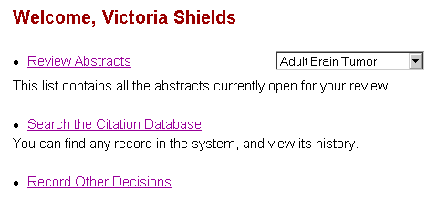

Citations ready for review are displayed in a list divided by summary topic and review cycle. Each citation is listed in a brief format that includes complete bibliographic information, summary topic(s), editorial board(s), and several identification numbers. Each citation is accompanied by a “Yes” and “No” check-box to the left. CIPS reviewers can use the check-boxes to quickly decide whether to review the full text of each citation on the basis of the brief bibliographic information or display the citation abstract by clicking on the brief record.

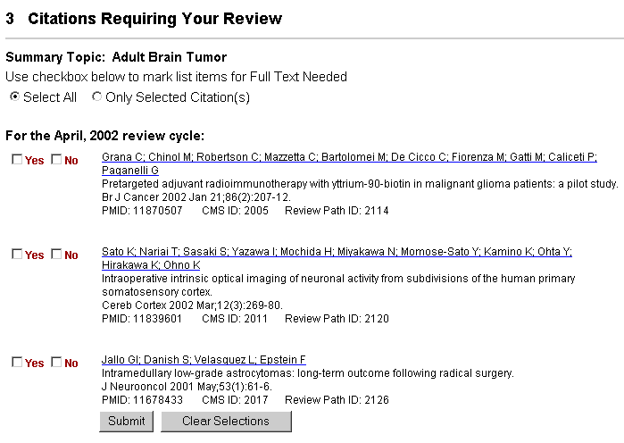

To review citations using the check-boxes, check either “Yes” or “No” as each citation is reviewed. After reviewing the citations, scroll to the end of the list and click “Submit.” Use the “Clear Selections” button to un-check all the checked boxes. Check the “Select All” radio button at the top of the list to mark every citation in the list for full-text retrieval.

When you click “Submit,” a list of the citations selected for full-text retrieval will be displayed in addition to a list of those citations not selected for full-text retrieval. From this display, you can return to your list of current citations ready for review.

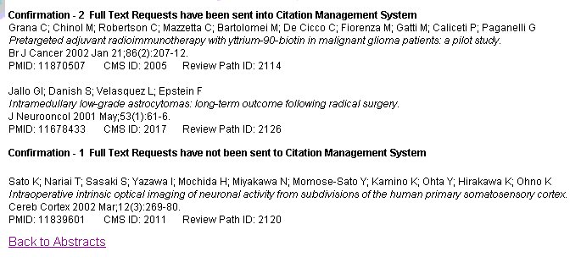

All citations reviewed will be removed from the CIPS reviewer’s list. Citations will remain on the CIPS reviewer’s list until each citation is reviewed, regardless of the review cycle.

If you would like to make comments about your decision to review the full text of a selected citation or if you require more information to make your decision, click on the brief record to display the citation abstract. Record your review decision and comments below the abstract, and then click “Submit.”

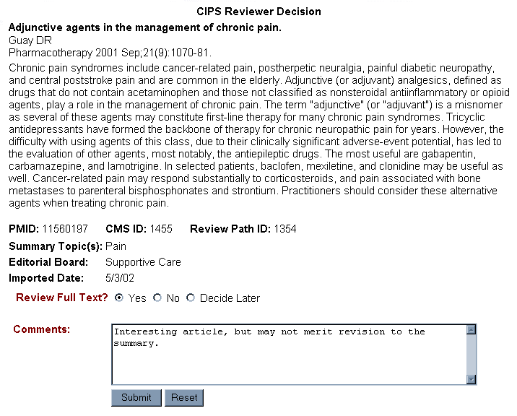

At the prompt, click “OK” to submit your decisions and comments, or click “Cancel” to delete them. When you click “OK,” the citation, your review decision and comments will be displayed. From this display, you can return to the list of current citations ready for review. The citation you just reviewed will be removed from the list. When you click “Cancel,” your review decision and comments will not be recorded. You can then make changes to your review decision and/or comments and resubmit or return to your list of current citations ready for review. The citation in which you just deleted your review decision and comments will remain on the list until it is reviewed again.

Search the Citation Database

Overview of Search Function
Use the “Search the Database” feature of the Citation Management System to retrieve any specific citation or group of citations in the Citation Management System Database, including citations previously reviewed as well as those currently in review. Search by any of the bibliographic fields as well as editorial board, summary topic, and citation identification numbers. Search retrieval can be limited by review cycle and citation status, including CIPS reviewer decision, CIPS literature surveillance committee decision, editorial board member review response, editorial board reviewer, and/or editorial board decision. Search results can be sorted by identification number, publication date, review cycle, journal title, author, editorial board, or summary topic.

Search the Database
To begin a search of the database, click “Search the Database” on the main menu or on the menu bar at the top of any screen. Using the search form, enter your search parameters in the appropriate search fields (see “Search Fields” below for details). When you are finished entering your search parameters, click “Search” to execute your search. Use the “Reset” button to clear the search form.

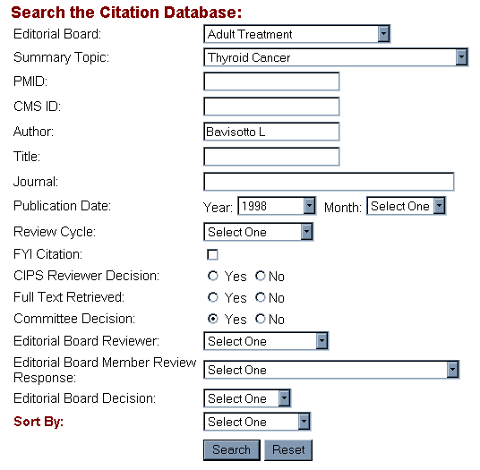

Search Fields

Below are listed the bibliographic and citation tracking/status fields available for searching the Citation Management System Database. A description and an example of each are provided. Any of these fields may be used alone or in combination while searching the database.

Editorial Board
Select one of the editorial boards from the pull-down menu to retrieve only those citations in the database that are assigned to that specific editorial board.

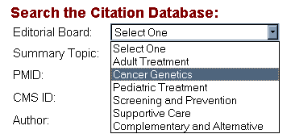

Summary Topic
Select one or more of the summary topics from the pull-down menu to retrieve only those citations in the database that are assigned to the selected summary topic(s). More than one summary topic can be selected by holding down the CTRL button in the lower left corner of the keyboard.

Most of the summary topics listed have corresponding PDQ® summaries with the same title. Summary topics followed by an asterisk are search topics that do not yet have a PDQ® summary associated with them.

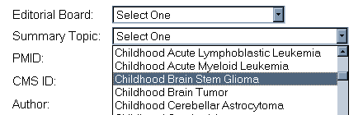

PMID#
Also known as the PubMed Unique Identifier, the PMID is an eight-digit number that uniquely identifies each citation record in PubMed. Enter the PMID# to retrieve a single, specific citation. Avoid using in combination with other search fields.

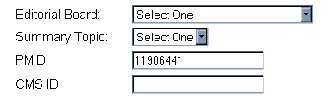

CMS ID#
Enter the CMS ID# to retrieve a single, specific citation. Avoid using in combination with other search fields.

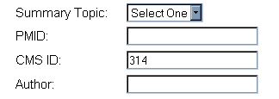

Author
Use the author field to retrieve citations published by a specific person. Enter the author’s last name, then enter a space followed by the author’s first and second initials. The author’s first and second initials are not required but may help to narrow retrieval.

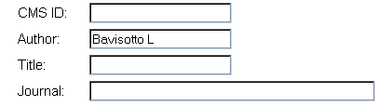

Title
Use the title field to retrieve a citation with a specific title or with specific words in the title. Enter the first few words in the title, or enter a single word or phrase from the title. Note: Words entered adjacent to each other will be required to have the same adjacency in the retrieved citation titles.

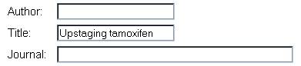

Journal
Use the journal field to retrieve only those citations published in a specific journal. Enter the full journal title or the NLM journal title abbreviation.

Full Journal Title:
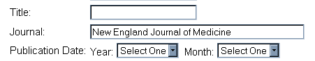

NLM Journal Abbreviation:
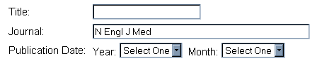

Publication Date
Use the publication date field to retrieve only those citations published during a specific year or during a specific month of a year. Select a month and/or a year from the pull-down menus.

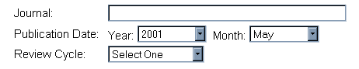

Review Cycle
Every month, literature searches are conducted, and the resulting citations are entered into the Citation Management System Database. Citations entered into the database are assigned a review cycle that designates the month and year the citations were added to the database. Select a review cycle from the pull-down menu to retrieve only those citations that were entered into the Citation Management System Database during a specific review cycle.

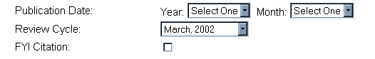

FYI Distribution*
Check the box to retrieve only those citations that were sent to editorial board members as an FYI.

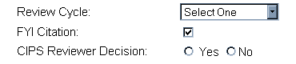

CIPS Reviewer Decision*
Select “Yes” or “No” to limit your retrieval on the basis of CIPS reviewer decision. If you select “Yes,” you will retrieve only those citations selected for full-text review. If you select “No,” you will retrieve citations that were not selected for further review.

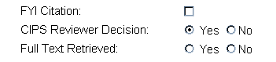

Full Text Retrieved*
Select “Yes” or “No” to limit your retrieval on the basis of whether the full text of the citation has been retrieved. If you select “Yes,” you will retrieve only those citations that were selected by the CIPS reviewer for full-text review and that have been photocopied. If you select “No,” you will retrieve only those citations that were selected by the CIPS reviewer for full-text review and that have not yet been photocopied.

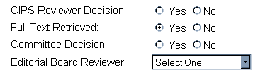

CIPS Literature Surveillance Committee Decision*
Select “Yes” or “No” to limit your retrieval on the basis of whether the literature surveillance committee decided to send the citation to selected editorial board members for further review. If you select “Yes,” you will retrieve only those citations that were selected by the committee for further editorial board member review. If you select “No,” you will retrieve only those citations that were not selected for further review.

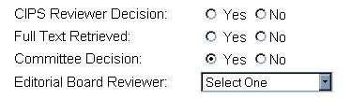

Editorial Board Reviewer*
Select the name of the editorial board member from the pull-down menu to retrieve only those citations that were reviewed by the selected editorial board member.

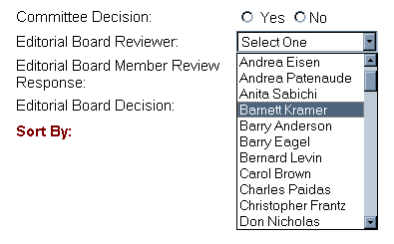

Editorial Board Member Review Response*
Select a reviewer response from the pull-down menu to retrieve only those citations that were assigned the selected response when reviewed by the selected editorial board member(s).

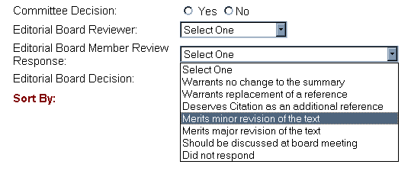

Editorial Board Decision*
Select “Yes” or “No” to limit your retrieval on the basis of the editorial board decision to cite the citations selected for full editorial board meeting discussion. If you select “Yes,” you will retrieve only those citations that were discussed at a full editorial board meeting and that were selected by the board to be cited. If you select “No,” you will retrieve only those citations that were discussed at a full editorial board meeting and that were not selected by the board to be cited.

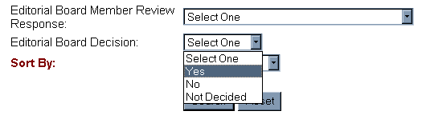

*Note: When using any of the following fields in combination, please keep in mind that they reflect sequential steps and decisions in the literature surveillance citation review process: CIPS Reviewer Decision, Full Text Retrieved, CIPS Literature Surveillance Committee Decision, Editorial Board Reviewer, Editorial Board Member Review Response, Editorial Board Decision and FYI Distribution. If use of these fields does not reflect the process correctly, the search will not retrieve any citations. For example, if you limit your retrieval with CIPS review decision “no” AND committee decision “yes,” you will not retrieve any citations because citations that receive CIPS review decision “no” will most likely never receive committee decision “yes” (or any other review decision).

Sort Citation Records
Before submitting your search request, select from the pull-down menu to sort your search results by identification number, publication date, review cycle, journal title, author, editorial board, or summary topic.

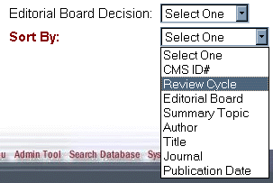

Display Citation Records
Search results are displayed in a brief format that includes complete bibliographic information, summary topic(s), editorial board(s), and identification numbers. From the search results list, click on the brief citation record to view the abstract. From the abstract display, there is an option to return to the list of search results or to view the citation’s history (see View Citation History section below for details).

View Citation History
From the abstract display of a citation retrieved from your search of the database, click on one of the review paths to view decisions made regarding that specific citation. Most citations will have only one review path because most citations are assigned to only one editorial board. Each review path records review decisions made for a single editorial board and contains the name of the editorial board and the date on which the citation review was initiated. If a citation is revisited or reviewed a second time for a different editorial board, a new review path can be generated with a new review initiation date. This, in turn, will allow the CIPS reviewer assigned to that editorial board to make changes to that citation.

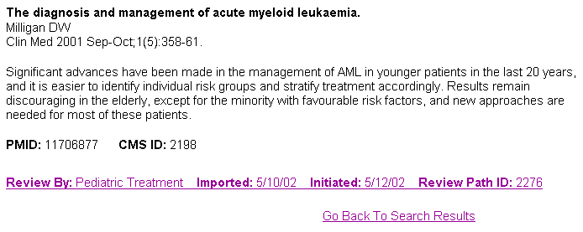

From the View History display, each step of the review process is listed in order with the date, decision, and comments listed below. CIPS staff have the option to change any citation that is assigned to their editorial board or to the Adult Treatment editorial board. If the citation that you are viewing is assigned to your board or to the Adult Treatment board, add buttons will be displayed automatically beside each step of the review process that has been completed to date.

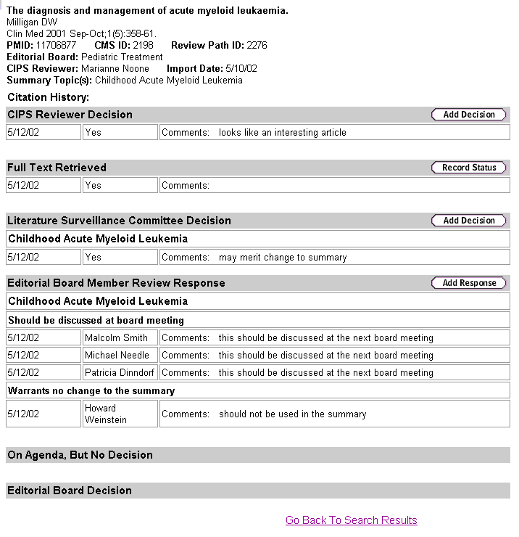

Record Review Decisions for a Specific Citation
By clicking on one of the add buttons, you can record additional/new decisions for that step in the review process. Click the add button on the gray bar for the decision that you wish to record. Record your decisions and comments in the space provided, and click “Submit.” At the prompt, review your decision and comments. Click “OK” to submit, or click “Cancel” to delete. When you click “OK,” your decisions and comments will be displayed. From this confirmation screen, you can return to your search results.

If for some reason the citation selected to be discussed is not discussed at the next editorial board meeting, or no decision was made, then a comment can be recorded noting why and when it is planned to be discussed. To add a comment, on the “On Adenda, But No Decision” gray bar, click “Add Comment.” Record your comment in the space provided, and then click “Submit.”

Note: Changes can be made only up to the latest step where the citation is in the current review process. To ensure that citations are properly tracked and disseminated, CIPS staff are not permitted to skip steps in the review process. If you need to skip a step in the review process for a specific citation, please contact the onsite Aspen staff member.

If the citation that you are viewing is not assigned to your board or to the Adult Treatment board, add buttons will not be displayed.

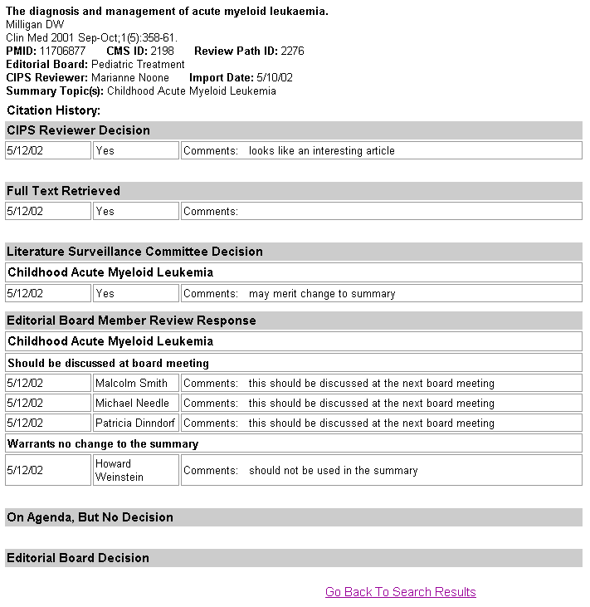

Record Review Decisions for Citations Currently in Review

To record other review decisions in the Citation Management System—including the CIPS literature surveillance committee decision, the editorial board member review response, or citations to be discussed at the editorial board meeting for citations currently in review—on the main menu click “Record Other Decisions,” then select a review decision, summary topic, and/or review cycle.

Please note that these review decision are systematically recorded by an onsite Aspen staff member. If you decide to record any of these decisions, please contact the onsite Aspen staff member to prevent duplication of work as well as a break in the citation tracking and dissemination work flow.

Record CIPS Literature Surveillance Committee Decision

Citations selected by the CIPS reviewers for full-text review will be retrieved, photocopied, and discussed at the next literature surveillance committee meeting. The committee will review the full text and decide whether the citation should be reviewed by selected editorial board members for specific summary topics.

A list of current citations awaiting a committee decision can be generated using the pull-down menus. Select “CIPS Literature Surveillance Committee Decision,” a summary topic, and/or a review cycle; click “Submit” to display the results in a list.

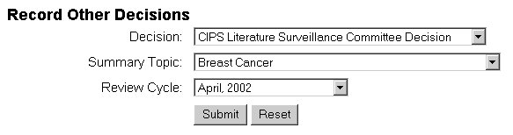

To record the committee decision, click on one of the brief citation records from this list. Record the committee decision by selecting “Yes” or “No,” and then enter any decision comments in the space provided. If a citation is relevant to more than one summary topic, the committee may make several decisions about the same citation with respect to each relevant summary topic. Therefore, if the committee decision is “Yes,” summary topics must also be selected from the pull-down menu. This not only records that the committee has decided to send the citation to be reviewed by selected editorial board members and which specific summary topic it is to be reviewed for, but also records by default which editorial board members will review the citation because each editorial board member is assigned to review citations for specific summary topic(s). More than one summary topic can be selected by holding down the CTRL button in the lower left corner of the keyboard.

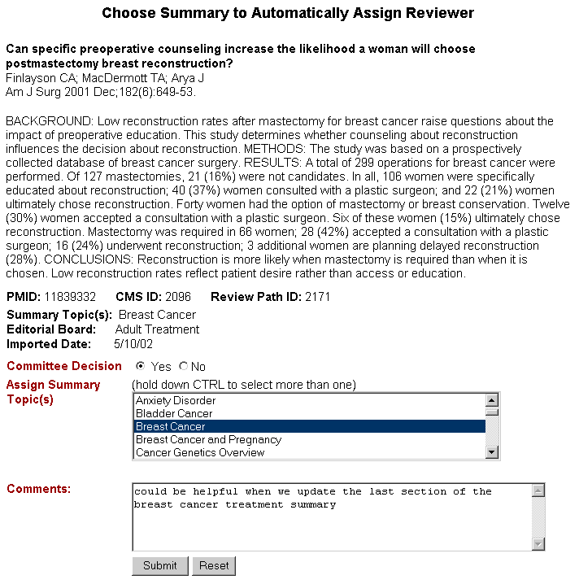

Click on the “Submit” button. At the prompt, review your committee decision and comments. Click “OK” to submit your committee decision and comments, or click “Cancel” to delete them. When you click “OK,” the citation, committee decision, and comments will be displayed. From this display, you can return to your list of citations awaiting committee decision. The citation for which you just recorded a committee decision and comments will be removed from the list. When you click “Cancel,” your committee decision and comments will not be recorded. You can then make changes to your committee decision and comments and resubmit or return to the list of citations requiring committee decisions. The citation for which you did not record a committee decision and comments will remain on the list until a decision is recorded.

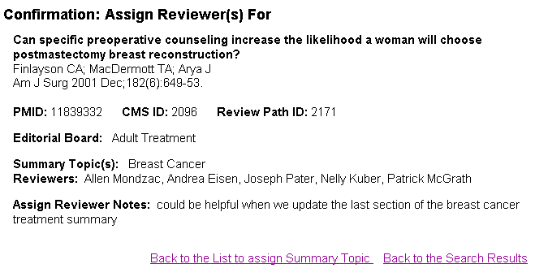

Record Editorial Board Member Review Response

After the literature surveillance committee selects citations for further editorial board member review, full-text copies of these citations are mailed with cover sheets to the appropriate editorial board member(s). Responses are returned on the cover sheets and are then recorded in the database.

A list of current citations awaiting a committee decision can be generated using the pull-down menus. Select “Record Editorial Board Member Review Response,” a summary topic, and/or a review cycle; click “Submit” to display the results in a list.

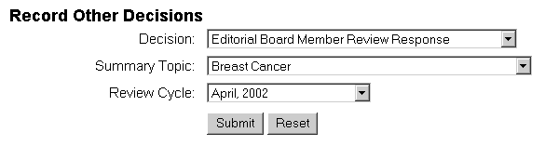

Below each brief record is a pull-down menu listing each editorial board member and the corresponding summary topic that the citation was sent to for review.

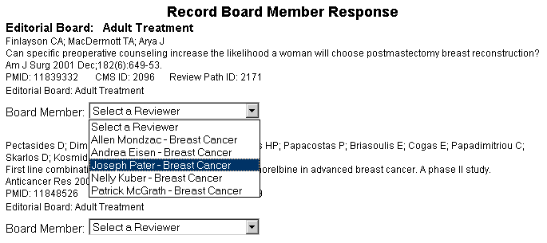

This pull-down menu is generated from committee decisions and their assigned summary topics. If a citation is relevant to more than one summary topic, the committee may make several decisions about the same citation with respect to each relevant summary topic. A summary topic and the name of the editorial board member responsible for that summary topic are listed in the pull-down menu for each committee decision that was made. A board member may appear more than once with different summary topics if that board member is responsible for reviewing citations for more than one summary topic. Also, more than one board member may be assigned to a single summary topic.

To record a specific board member’s review response for a specific citation, select the editorial board member-summary topic from the pull-down menu below the brief citation record. Select the board member’s review response from the pull-down menu, record any comments in the space provided, and then click “Submit.”

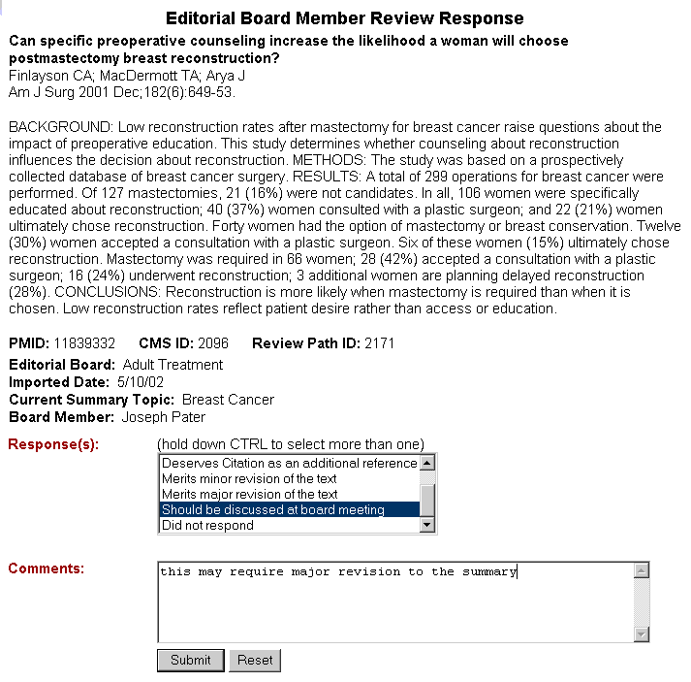

At the prompt, review the response and comments. Click “OK” to submit your response and comments, or click “Cancel” to delete them. When you click “OK,” the citation, review response, and comments will be displayed. From this display, you can return to the list of citations that were sent to selected editorial board members for further review. The editorial board member-summary topic for which you just recorded a response will be removed from the pull-down menu. The citation will remain in the list until responses are recorded for each editorial board member-summary topic listed in the pull-down menu. When “Cancel” is clicked, the editorial board member’s review response and comments will not be recorded. You can then make changes to your review response and comments, and resubmit or return to the list of all citations that were sent to selected members for further review. The editorial board member-summary topic that you did not record a response for will not be removed from the pull-down menu.

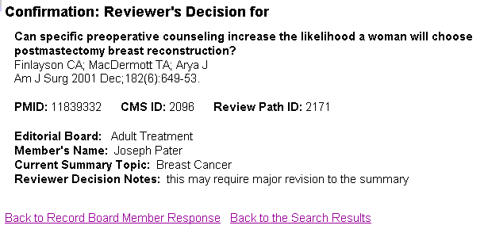

If the editorial board member does not return a review response for the citation in the time allowed, select “Did Not Respond” from the pull-down menu. If an editorial board member returns a response after “Did Not Respond” has already been recorded for that citation, then the editorial board member’s review response can be recorded by searching the database and viewing the citation history. The View Citation History display provides options to add citation decisions. CIPS staff can only record decisions for citations that are assigned to their editorial board or to the Adult Treatment editorial board. (See Record Citation Decisions for a Specific Citation under Searching the Database.)

Citations To Be Discussed at Editorial Board Meeting

The editorial board member review responses are returned and recorded in the database. An editorial board member may indicate that a citation warrants no change to the summary, warrants replacement of a reference, deserves citation as an additional reference, or merits minor or major revision of the text. All necessary changes are then made to the appropriate PDQ® summary. An editorial board member may also indicate that a citation needs to be discussed at a full editorial board meeting. The citation is discussed at the next editorial board meeting if time permits. All decisions made by the editorial board at the meeting regarding the citation are recorded in the database, and the necessary changes are then made to the appropriate PDQ® summary.

A list of current citations to be discussed at the next editorial board meeting can be generated using the pull-down menus under “Citations to be Discussed at Editorial Board Meeting.” Select an editorial board and/or summary topic, and then click “Submit” to display the results in a list.

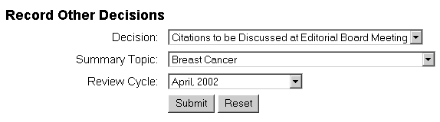

To record the editorial board decision, click on one of the brief citation records from this list.

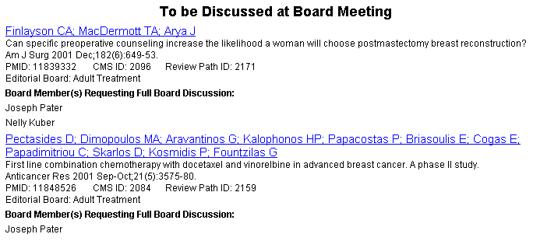

Record the editorial board decision by selecting “Yes” or “No,” select the summary topic(s) in which the citation will be referenced, enter any decision comments in the space provided, and then click “Submit.” More than one summary topic can be selected by holding down the CTRL button in the lower left corner of the keyboard.

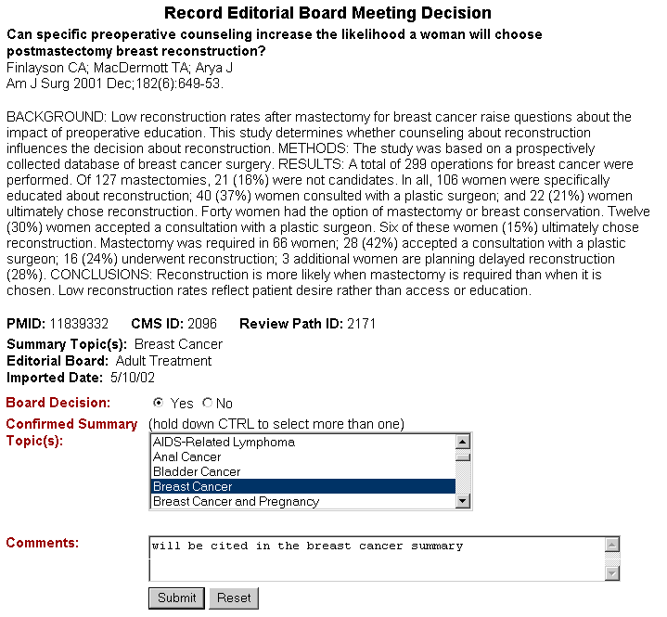

At the prompt, review your editorial board decision and comments. Click “OK” to submit your editorial board decision and comments, or click “Cancel” to delete them. When you click “OK,” the citation, editorial board decision, and comments will be displayed. From this display, you can return to your list of citations to be discussed. The citation for which you recorded an editorial board decision will be removed from the list. When you click “Cancel,” your editorial board decision and comments will not be recorded. You can then make changes to your decision and comments and resubmit or return to the list of citations to be discussed. The citation for which you did not record an editorial board decision and comments will remain on the list until a decision is recorded.

System Help

At the top of any screen, click “System Help” to open an online version of this documentation. From the CMS Help window, use the table of contents in the left side bar to navigate the documentation. Click on the “+” to expand the table of contents.
Section II: Citation Tracking and Dissemination

Citations Requiring Full-Text Retrieval

A list of current citations requiring full-text retrieval can be generated using the pull-down menus under “Citations Requiring Full-text Retrieval” listed from the main menu. Select an editorial Board, summary topic, CIPS Reviewer, and/or a review cycle; click “Submit” to display the results in a list.

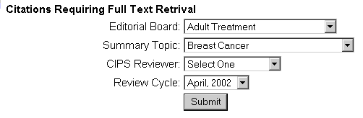

To record whether the full text of a citation has been retrieved, click on one of the brief citation records from the list. Record the retrieval status by checking “Yes” or “No,” and then enter any comments regarding the retrieval status in the space provided. Click “Submit.” Checking “Yes” that the full text of the citation has been retrieved removes the citation from the current list of citations requiring full-text retrieval. Checking “No” that the full text of the citation has not been retrieved leaves the citation on the list; any comments regarding the retrieval status will be displayed when the citation record is viewed again.

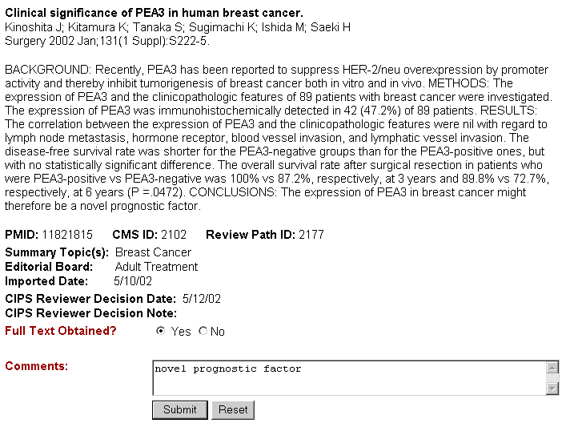

At the prompt, review the full-text retrieval status. Click “OK” to submit, or click “Cancel.” When you click “OK,” a confirmation screen will display the full-text retrieval status and comments. When you click “Cancel,” the full-text retrieval status and comments will not be recorded; you can then make changes to the status and comments and resubmit or return to the list of current citations requiring full-text retrieval.

From the confirmation screen, you can return to the list of citations requiring full-text retrieval or click on “Print Cover Sheet” to generate a cover sheet to attach to the full-text copy of the citation for the literature surveillance committee meeting. After the cover sheet has displayed, use your browser’s print icon at the top of the screen to print it.

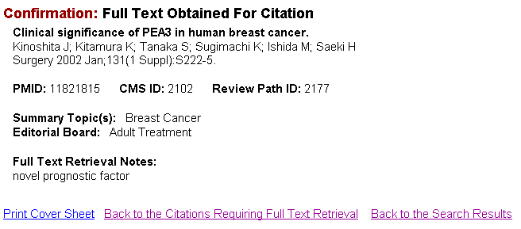

This cover sheet can also be printed from the brief record display of the list of citations requiring full-text retrieval. Click on “Print Cover Sheet” just below the brief citation record to generate a cover sheet to attach to the full-text copy of the citation for the literature surveillance committee meeting. After the cover sheet has displayed, use your browser’s print icon at the top of the screen to print it.

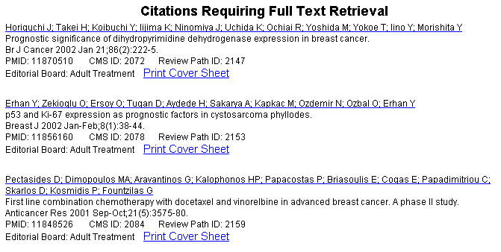

Record Literature Surveillance Committee Decision

Citations selected by CIPS reviewers for full-text review will be retrieved, photocopied, and discussed at the next literature surveillance committee meeting. The committee will review the full text and decide which citations should be reviewed by selected editorial board members for specific summary topics.

A list of current citations awaiting a committee decision can be generated using the pull-down menus. Select an editorial board, summary topic, CIPS reviewer, and/or a review cycle; click “Submit” to display the results in a list.

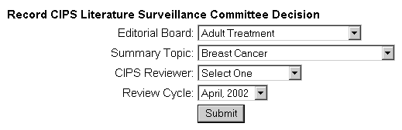

From the brief list of current citations awaiting a committee decision, you can either record the committee decision or flag the citation for FYI distribution.

To record the committee decision, click on one of the brief citation records from this list. Record the committee decision by selecting “Yes” or “No,” and then enter any decision comments in the space provided. If a citation is relevant to more than one summary topic, the committee may make several decisions about the same citation with respect to each relevant summary topic. Therefore, if the committee decision is “Yes,” summary topics must also be selected from the pull-down menu. This not only records that the committee has decided to send the citation to be reviewed by selected editorial board members and which summary topic it is to be reviewed for, but also records by default which editorial board members will review the citation because each editorial board member is assigned to review citations for specific summary topic(s). More than one summary topic can be selected by holding down the CTRL button in the lower left corner of the keyboard.

Click the “Submit” button. At the prompt, review your committee decision and comments. Click “OK” to submit your committee decision and comments, or click “Cancel” to delete them. When you click “OK,” the citation, committee decision, and comments will be displayed. From this display, you can return to your list of citations awaiting committee decision. The citation for which you just recorded a committee decision and comments will be removed from the list. When you click “Cancel,” your committee decision and comments will not be recorded. You can then make changes to your committee decision and comments, and resubmit or return to the list of citations requiring committee decisions. The citation for which you did not record a committee decision and comments will remain on the list until a decision is recorded.

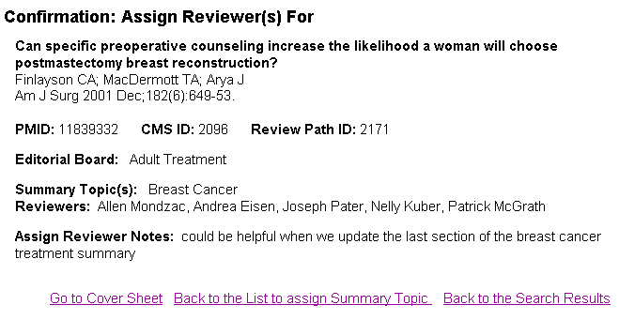

From the confirmation screen, you can return to the list of citations awaiting a committee decision or click on “Go to Cover Sheet” to generate a cover sheet to attach to the full-text copy of the citation to send to selected editorial board members for further review. After the cover sheet has displayed, use your browser’s print icon at the top of the screen to print it.

To flag a citation for FYI distribution, click on “Flag for FYI” beside a brief record in the list of current citations awaiting a committee decision.

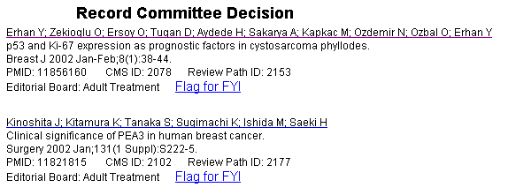

Record a comment in the space provided and then click “Submit.” You can then return to your list of current citations awaiting a committee decision from the confirmation screen.

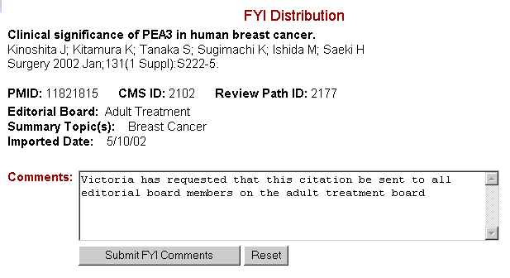

Record Editorial Board Member Review Response

After the literature surveillance committee selects citations for further editorial board member review, full-text copies of these citations are mailed with cover sheets to the appropriate editorial board member(s). Their responses are returned on the cover sheets and are then recorded in the database.

A list of current citations awaiting editorial board member review response can be generated using the pull-down menus. Select an editorial board, summary topic, CIPS reviewer, and/or a review cycle; click “Submit” to display the results in a list.

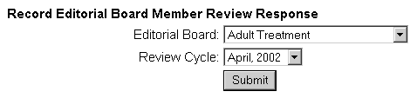

Below each brief record is a pull-down menu listing each editorial board member and the corresponding summary topic that the citation was sent to for review.

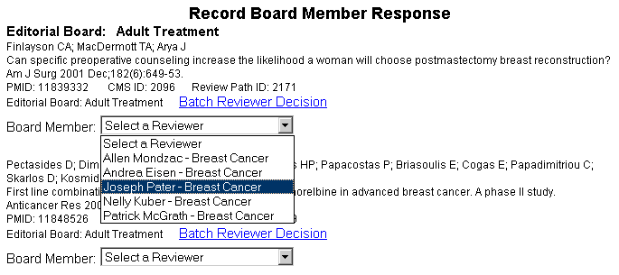

This pull-down menu is generated from committee decisions and their assigned summary topics. If a citation is relevant to more than one summary topic, the committee may make several decisions about the same citation with respect to each relevant summary topic. A summary topic and the name of the editorial board member responsible for that summary topic are listed in the pull-down menu for each committee decision that was made. A board member may appear more than once in this list if that board member is responsible for reviewing citations for more than one summary topic. Also, more than one board member may be assigned to a single summary topic.

To record a specific board member’s review response for a specific citation, select the editorial board member-summary topic from the pull-down menu below the brief citation record. Select the board member’s review response from the pull-down menu, record any comments in the space provided, and then click “Submit.”

To record the same review response for more than one editorial board member at a time, click on “Batch Reviewer Decision” beside a brief record from the list of current citations awaiting an editorial board member review response. Use the control key in the bottom left corner of your keyboard to select more than one reviewer. Select a review response and enter any comments in the space provided then click “Submit.”

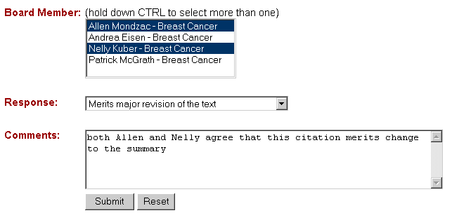

At the prompt, review the response and comments. Click “OK” to submit your response and comments, or click “Cancel” to delete them.

When you click “OK,” the citation, review response, and comments will be displayed. From this display, you can return to the list of citations that were sent to selected editorial board members for further review. The editorial board member-summary topic for which you just recorded a response will be removed from the pull-down menu. The citation will remain in the list until responses are recorded for each editorial board member-summary topic listed in the pull-down menu. When you click “Cancel,” the editorial board member’s review response and comments will not be recorded. You can then make changes to your review response and comments, and resubmit or return to the list of all citations that were sent to board members for further review. The editorial board member-summary topic that you did not record a response for will not be removed from the pull-down menu.

If an editorial board member does not return a review response for the citation in the time allowed, select “Did Not Respond” from the pull-down menu. If an editorial board member returns a response after “Did Not Respond” has already been recorded for that citation, the editorial board member’s review response can be recorded by searching the database and viewing the citation history. The View Citation History display provides options to add review decisions. CIPS staff can only record decisions for citations that are assigned to their editorial board or to the Adult Treatment editorial board. (See Record Citation Decisions for a Specific Citation under Searching the Database.)

Citations To Be Discussed at Editorial Board Meeting

Editorial board member review responses are returned and recorded in the database. An editorial board member may indicate that a citation warrants no change to the summary, warrants replacement of a reference, deserves citation as an additional reference, or merits minor or major revision of the text. All necessary changes are then made to the appropriate PDQ® summary. An editorial board member may also indicate that a citation needs to be discussed at a full editorial board meeting. The citation is discussed at the next editorial board meeting if time permits. All decisions made by the editorial board at the meeting regarding the citation are recorded in the database, and the necessary changes are then made to the appropriate PDQ® summary.

A list of current citations to be discussed at the next editorial board meeting can be generated using the pull-down menus under “Citations to be Discussed at Editorial Board Meeting.” Select an editorial board and/or summary topic, and then click “Submit” to display the results in a list.

To record the editorial board decision, click on one of the brief citation records from this list.

Record the editorial board decision by selecting “Yes” or “No,” select the summary topic(s) in which the citation will be referenced, enter any decision comments in the space provided, and click “Submit.” More than one summary topic can be selected by holding down the CTRL button in the lower left corner of the keyboard.

At the prompt, review your editorial board decision and comments. Click “OK” to submit your editorial board decision and comments, or click “Cancel” to delete them. When you click “OK,” the citation, editorial board decision, and comments will be displayed. From this display, you can return to your list of citations to be discussed at an editorial board meeting. The citation for which you recorded an editorial board decision will be removed from the list. When you click “Cancel,” your editorial board decision and comments will not be recorded. You can then make changes to your decision and comments, and resubmit or return to the list of citations to be discussed at an editorial board meeting. The citation for which you did not record an editorial board decision and comments will remain on the list until a decision is recorded.

Search the Citation Database

Overview of Search Function
Use the “Search the Database” feature of the Citation Management System to retrieve any specific citation or group of citations in the Citation Management System Database, including citations previously reviewed as well as those currently in review. Search by any of the bibliographic fields as well as editorial board, summary topic, and citation identification numbers. Search retrieval can be limited by review cycle and citation status, including CIPS reviewer decision, CIPS literature surveillance committee decision, editorial board member review response, editorial board reviewer, and/or editorial board decision. Search results can be sorted by identification number, publication date, review cycle, journal title, author, editorial board, or summary topic.

Search the Database
Click “Search the Database” on the main menu or on the menu bar at the top of any screen, to begin a search of the database. Using the search form, enter your search parameters in the appropriate search fields (see “Search Fields” below for details). When you are finished entering your search parameters, click “Search” to execute your search. Use the “Reset” button to clear the search form.

Search Fields

Below are listed the bibliographic and citation tracking/status fields available for searching the Citation Management System Database. A description and an example of each are provided. Any of these fields may be used alone or in combination while searching the database.

Editorial Board
Select one of the editorial boards from the pull-down menu to retrieve only those citations in the database that are assigned to that specific editorial board.

Summary Topic
Select one or more of the summary topics from the pull-down menu to retrieve only those citations in the database that are assigned to the selected summary topic(s). More than one summary topic can be selected by holding down the CTRL button in the lower left corner of the keyboard.

Most of the summary topics listed have corresponding PDQ® summaries with the same title. Summary topics followed by an asterisk are search topics that do not yet have a PDQ® summary associated with them.

PMID#
Also known as the PubMed Unique Identifier, the PMID is an eight-digit number that uniquely identifies each citation record in PubMed. Enter the PMID# to retrieve a single, specific citation. Avoid using in combination with other search fields.

CMS ID#
Enter the CMS ID# to retrieve a single, specific citation. Avoid using in combination with other search fields.

Author
Use the author field to retrieve citations published by a specific person. Enter the author’s last name, then enter a space followed by the author’s first and second initials. The author’s first and second initials are not required but may help to narrow retrieval.

Title
Use the title field to retrieve a citation with a specific title or with specific words in the title. Enter the first few words in the title, or enter a single word or phrase from the title. Note: Words entered adjacent to each other will be required to have the same adjacency in the retrieved citation titles.

Journal
Use the journal field to retrieve only those citations published in a specific journal. Enter the full journal title or the NLM journal title abbreviation.

Full Journal Title:

NLM Journal Abbreviation:

Publication Date
Use the publication date field to retrieve only those citations published during a specific year or during a specific month of a year. Select a month and/or a year from the pull-down menus.

Review Cycle
Every month, literature searches are conducted, and the resulting citations are entered into the Citation Management System Database. Citations entered into the database are assigned a review cycle that designates the month and year the citations were added to the database. Select a review cycle from the pull-down menu to retrieve only those citations that were entered into the Citation Management System Database during a specific review cycle.

FYI Distribution*
Check the box to retrieve only those citations that were sent to editorial board members as an FYI.

CIPS Reviewer Decision*
Select “Yes” or “No” to limit your retrieval on the basis of CIPS reviewer decision. If you select “Yes,” you will retrieve only those citations selected for full-text review. If you select “No,” you will retrieve citations that were not selected for further review.

Full-text Retrieved*
Select “Yes” or “No” to limit your retrieval on the basis of whether the full text of the citation has been retrieved. If you select “Yes,” you will retrieve only those citations that were selected for full-text review and that have been photocopied. If you select “No,” you will retrieve only those citations that were selected for full-text review and that have not yet been photocopied.

CIPS Literature Surveillance Committee Decision*
Select “Yes” or “No” to limit your retrieval on the basis of whether the literature surveillance committee decided to send the citation to selected editorial board members for further review. If you select “Yes,” you will retrieve only those citations that were selected by the committee for further editorial board member review. If you select “No,” you will retrieve only those citations that were not selected for further review.

Editorial Board Reviewer*
Select the name of the editorial board member from the pull-down menu to retrieve only those citations that were reviewed by the selected editorial board member.

Editorial Board Member Review Response*
Select a reviewer response from the pull-down menu to retrieve only those citations that were assigned the selected response when reviewed by the selected editorial board member(s).

Editorial Board Decision*
Select “Yes” or “No” to limit your retrieval on the basis of the editorial board decision to cite the citations selected for full editorial board meeting discussion. If you select “Yes,” you will retrieve only those citations that were discussed at a full editorial board meeting and that were selected by the board to be cited. If you select “No,” you will limit your retrieval to only those citations that were discussed at a full editorial board meeting and that were not selected by the board to be cited.

*Note: When using any of the following fields in combination, please keep in mind that they reflect sequential steps and decisions in the literature surveillance citation review process: CIPS Reviewer Decision, Full Text Retrieved, CIPS Literature Surveillance Committee Decision, Editorial Board Reviewer, Editorial Board Member Review Response, Editorial Board Decision and FYI Distribution. If use of these fields does not reflect the process correctly, the search will not retrieve any citations. For example, if you limit your retrieval with CIPS review decision “no” AND committee decision “yes,” you will not retrieve any citations because citations that receive CIPS review decision “no” will most likely never receive committee decision “yes”(or any other review decision).

Sort Citation Records
Before submitting your search request, select from the pull-down menu to sort your search results by identification number, publication date, review cycle, journal title, author, editorial board, or summary topic.

Display Citation Records
Search results are displayed in a brief format that includes complete bibliographic information, summary topic(s), editorial board(s), and identification numbers. From the search results list, click on the brief citation record to view the abstract. From the abstract display, there is an option to return to the list of search results or to view the citation’s history (see View Citation History section below for details).

View Citation History
From the abstract display of a citation retrieved from your search of the database, click on one of the review paths to view decisions made regarding that specific citation. Most citations will have only one review path because most citations are assigned to only one editorial board. Each review path records review decisions made for a single editorial board and contains the name of the editorial board and the date that the citation review was initiated. If a citation is revisited or reviewed a second time for a different editorial board, a new review path can be generated with a new review initiation date.

Aspen staff have the option to change any citation in the database for any step in the review process. From the view history display, each step of the review process is listed in order with the date, decision, and comments listed below. Add buttons are displayed beside each step of the review process, along with several other buttons that allow Aspen staff to print cover sheets and flag citations for FYI distribution.

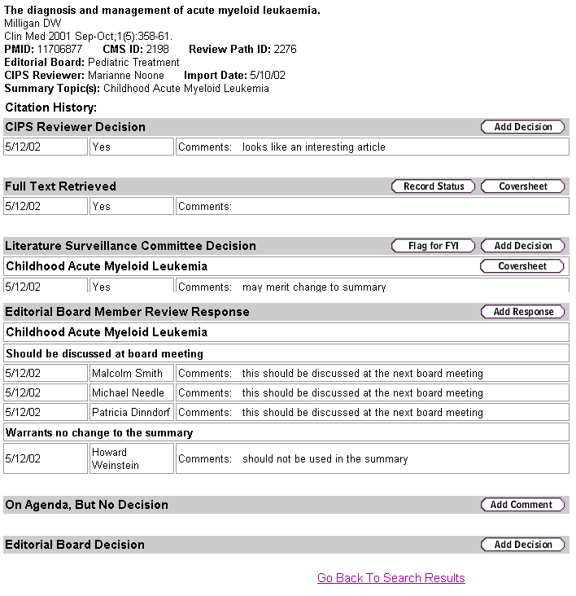

Record Review Decisions for a Specific Citation
By clicking on one of the add buttons, you can record additional/new decisions for that step in the review process. Click the add button on the gray bar for the decision that you wish to record. Record your decisions and comments in the space provided and click “Submit.” From the prompt dialog box, review your decision and comments. Click “OK” to submit or click “Cancel” to delete. Upon clicking “OK,” your decisions and comments will be displayed. From this confirmation screen, you can return to your search results.

If for some reason the citation selected to be discussed is not discussed at the next editorial board meeting, or no decision was made, then a comment can be recorded noting why and when it is planned to be discussed. To add a comment, on the “On Adenda, But No Decision” gray bar, click “Add Comment.” Record your comment in the space provided, and then click “Submit.”

To generate a cover sheet to attach to full-text articles for the literature surveillance committee meeting, click the “Cover Sheet” button on the “Full Text retrieved” gray bar. To generate a cover sheet to attach to full-text articles to send to selected editorial board members for further review, click the “Cover Sheet” button on the “Literature Surveillance Committee Decision” gray bar. After the cover sheet has displayed, use your browser’s print icon at the top of the screen to print it.

Citation Database Administration: Admin Tool

The following database administration tasks can be accessed from the admin tool main menu. Click on “Admin tool” from the top of any screen within the Citation Tracking and Dissemination interface to access this menu.

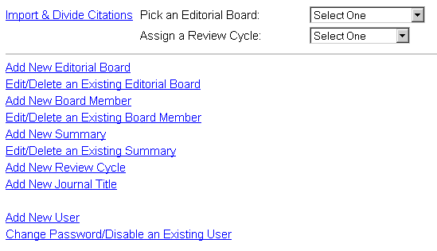

Import and Divide Citations
After citations are imported from PubMed into the database via the Citations Maintenance interface (see Section III: Citation Maintenance, below), they are “imported/published” to the other system interfaces and are ready for the review process to begin. Select an editorial board and review cycle to identify the batch of citations ready for import; click on “Import & Divide Citations.” The batch of citations that you selected will be displayed with a check-box beside each brief record. Specific citations can be marked for import, or all of the citations can be imported by selecting “Import All” and then clicking “Submit.” The number of citations imported will be displayed on the confirmation screen.

Add New Editorial Board
To add a new editorial board to the Citation Management System, on the admin tool main menu click “Add New Editorial Board.” Enter the name of the new editorial board, and then click “Save entry.” Click “Reset” to clear the entry form.

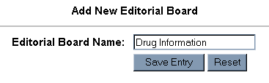

Edit/Delete an Existing Editorial Board
To edit or delete an existing editorial board in the Citation Management System, on the admin tool main menu click “Edit/Delete Existing Editorial Board.” Select an existing editorial board from the pull-down menu, and then click either “Edit” (to make a change to the name of the selected editorial board) or “Delete” (to delete the selected editorial board from the Citation Management System).

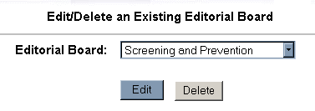

If you choose to edit an existing editorial board, the name of the editorial board selected will appear in a data entry box from which you can make any necessary changes. Use the “Reset” button to revert to the original editorial board name. When you are finished making changes, click “Save entry.”

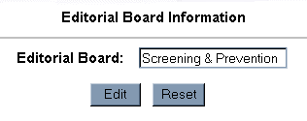
Note: When an editorial board name is edited, the name will be changed globally in the Citation Management System.

If you choose to delete an existing editorial board, click on the “Delete” button after selecting an editorial board from the pull-down menu. At the prompt, click “OK” to confirm that you want to delete the selected editorial board, or click “Cancel.”

Note: A deleted editorial board will no longer be used to index new citations, but will remain in all previous citations and continue to be available as a search parameter.

Add New Editorial Board Member
To add a new editorial board member to the Citation Management System, on the admin tool main menu click “Add New Editorial Board Member.” Enter the name of the board member, select the appropriate editorial board from the pull-down menu, select the summary topic(s) from the pull-down menu for which that member will be assigned to review citations, and click “Save Entry.” More than one summary topic can be selected by holding down the CTRL button in the lower left corner of the keyboard. Click “Reset” to clear the entry form and pull-down menu selections.

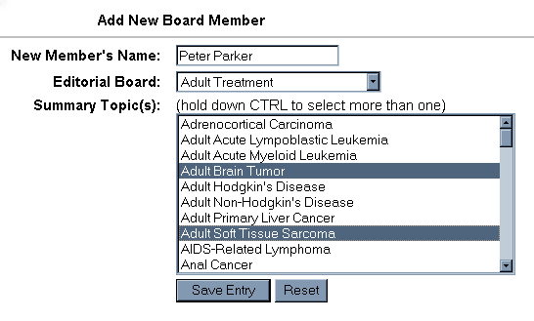

Edit/Delete an Existing Editorial Board Member
To edit or delete an existing editorial board member in the Citation Management System, on the admin tool main menu click “Edit/Delete Existing Editorial Board Member.” Select an existing member from the pull-down menu; click either “Edit” (to change the name and summary topic(s) assigned to that member) or “Delete” (to delete the selected editorial board member from the Citation Management System).

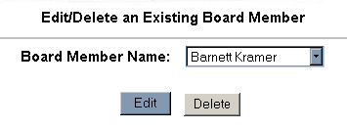

If you choose to edit an existing editorial board member, the name of the member you select will appear in a data entry box from which you can make any necessary changes. To change the summary topic(s) assigned to the selected editorial board member, select a member from the pull-down menu, and click on all of the summary topics to be assigned to that member. By default, those summary topics already assigned to the member appear highlighted at the top of the list. Use the “Reset” button to revert to the original editorial board member name and assigned summary topics. After you are finished making changes, click on “Save entry.”

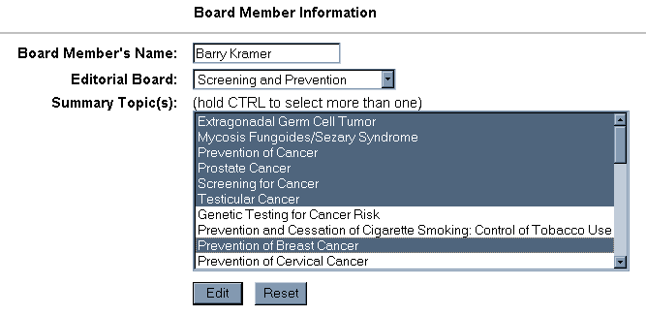
Note: When an editorial board member’s name is edited, the name will be changed globally in the Citation Management System.

If you choose to delete an existing editorial board member, click the “Delete” button after selecting a member from the pull-down menu. At the prompt, click “OK” to confirm that you want to delete the selected editorial board member, or click “Cancel.”

Note: A deleted editorial board member will no longer be used to index new citations, but will remain in all previous citations and continue to be available as a search parameter.

Add New Summary Topic
To add a new summary topic to the Citation Management System, on the admin tool main menu click “Add New Summary Topic.” Enter the name of the new summary topic, select the appropriate editorial board from the pull-down menu, and click “Save Entry.” Click “Reset” to clear the entry form and pull-down menu selections. Add an asterisk to the end of the summary topic if the topic does not yet have a corresponding PDQ® summary.

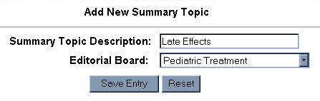

Edit/Delete an Existing Summary Topic
To edit or delete an existing summary topic in the Citation Management System, on the admin tool main menu click “Edit/Delete Existing Summary Topic.” Select an existing summary topic from the pull-down menu, and click either “Edit” (to change the existing summary topic) or “Delete” (to delete the selected summary topic from the Citation Management System).

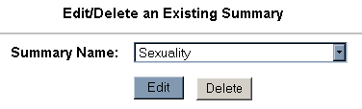

If you choose to edit an existing summary topic, the name of the summary topic you select will appear in a data entry box from which you can make any necessary changes. Use the “Reset” button to revert to the original summary topic. When you are finished making changes, click on “Save entry.”

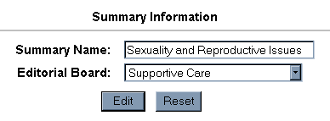
Note: When a summary topic is edited, the name will be changed globally in the Citation Management System.

If you choose to delete an existing summary topic, click the “Delete” button after selecting a summary topic from the pull-down menu. At the prompt, click “OK” to confirm that you want to delete the selected summary topic, or click “Cancel.”

Note: A deleted summary topic will no longer be used to index new citations, but will remain in all previous citations and continue to be available as a search parameter.

Add New Review Cycle
Review cycles are added each month and assigned to the monthly literature search results upon import to the Citation Management System. To add a new review cycle to the Citation Management System, on the admin tool main menu click “Add New Review Cycle.” Enter the new review cycle and then click “Save Entry.” Click “Reset” to clear the entry form.

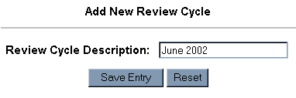

Add New User
To add a new user to the Citation Management System, on the admin tool main menu click “Add New User.” Enter the name of the new user, then enter and confirm the user’s password. If the user is a CIPS staff member, check the “CIPS User?” box and then assign the CIPS user an editorial board from the pull-down menu. Click “Save Entry,” or click “Reset” to clear the entry form and pull-down menu selections.

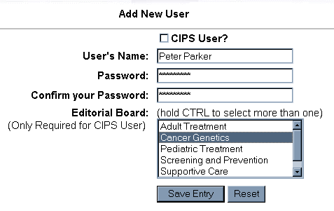

Add New Journal Title
To add a new journal title to the database journal title/journal abbreviation lookup table that allows users to search via full title and abbreviation, click on “Add New Journal Title.” Enter the full journal title and official NLM abbreviation in the space provided. Click “Save Entry,” or click “Reset” to clear the entry form and pull-down menu selections.

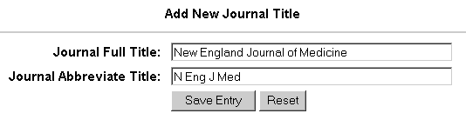

Change Password/Disable an Existing User
To change a user’s password or disable an existing user in the Citation Management System, on the admin tool main menu click “Change Password/Disable an Existing User.” Select an existing user from the pull-down menu. To change the user’s password, enter and confirm the new password, and then click “Change.”

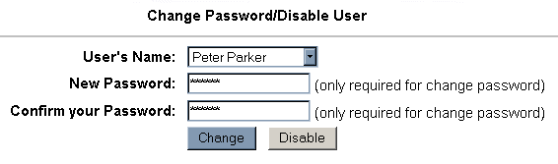

To disable an existing user, after selecting the username from the pull-down menu, click “Disable,” leaving the password text boxes blank. At the prompt, click “OK” to confirm that you want to disable the selected user, or click “Cancel.”

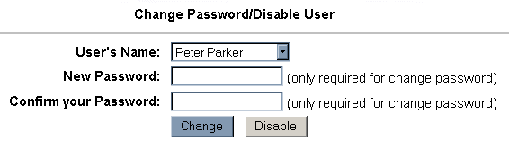
Section III: Citation Maintenance

Create Text File of Search Results

After conducting a search of the literature in a bibliographic database, save the results of each search strategy in a separate text file. Most bibliographic databases provide the option to save search results in a text file but the procedure may vary with each. The following are brief descriptions of how to create text files from those bibliographic databases currently being used for literature surveillance.

PubMed

After conducting the search, display all of the search results on one screen by clicking on the “Show” pull-down menu and selecting a higher number than the total number of search results. Select the “MEDLINE” display format from the “Display” pull-down menu. Click the “Display” button and then PubMed will redisplay your citations according to your selection. Next, click the “Text” button. PubMed will then display the results in a text format.
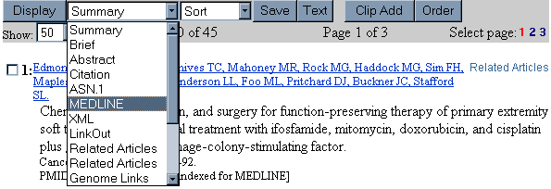
From the Text display, select “Save as” from the browser “File” menu. Select where the file will be saved and name the file accordingly. Select “Text file” from the “Save as type” pull-down menu and then click “Save.”
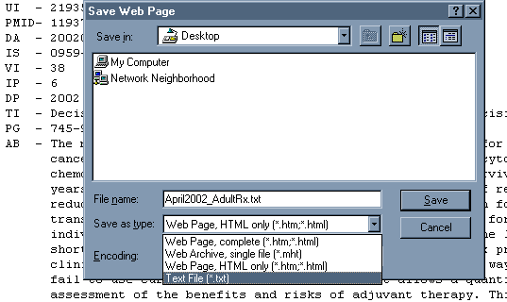

TOXLINE
After conducting the search, check the boxes beside each citation in the search results that you want to include in the text file. Click on the “Save Checked Items” button from the left side bar.

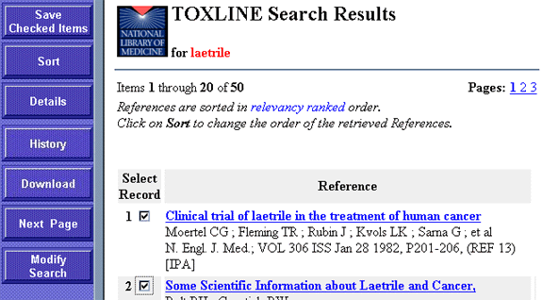

The number of saved items will be displayed. Click on the “Display Saved Items” button and then the “Download” button both from the left side bar. A small window will pop open where the number of records to be downloaded, the number of the record to start with and the format can be indicated. Select the “Tagged” format and then click the “Download” button.

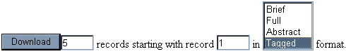

Import Text File to Import Utility

From your desktop using the CMS Import Utility short cut, open the import utility. To import a text file of search results, first select the search source, editorial board, summary topic and review cycle that identifies the batch of search results that you are importing. Then select the text file and click “Import.”

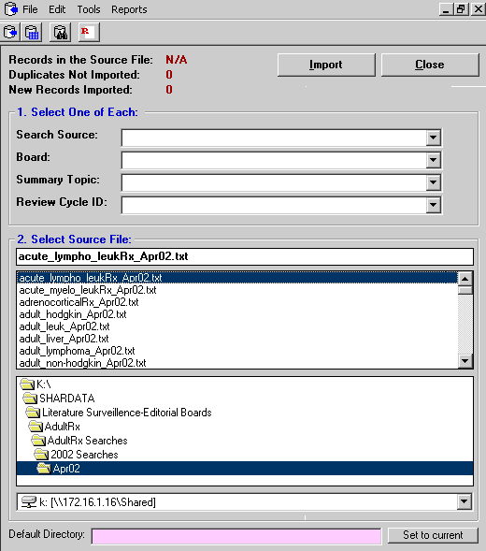

After the citations are successfully imported, the number of records in the source file, the number of duplicates that were not imported and the number of new records imported are displayed. If a duplicate was identified by the system the citation is only partially imported. The unique summary topics and review cycles are appended to the existing citation record.

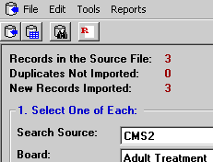

Review Search Results

Citations are reviewed by selected Aspen staff before they are “imported/published” to the other system interfaces and ready to begin the review process. Aspen staff can reject a citation for a specific summary topic by double clicking on that summary topic from the record display. An “R” will appear next to that summary topic and when the citations is later imported/published, the rejected summary topic will not be linked to the citation record.

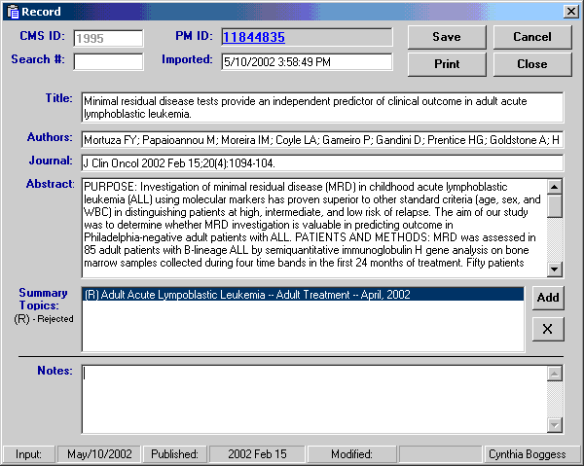

Aspen staff can also assign a new summary topic to a specific citation by clicking on the add button next to the list of summary topics. A list of summary topics is then displayed and the summary topic to be added to the record is selected. If the summary topic is to be added for a different review cycle, select a new review cycle from the pull-down menu before clicking “OK.”

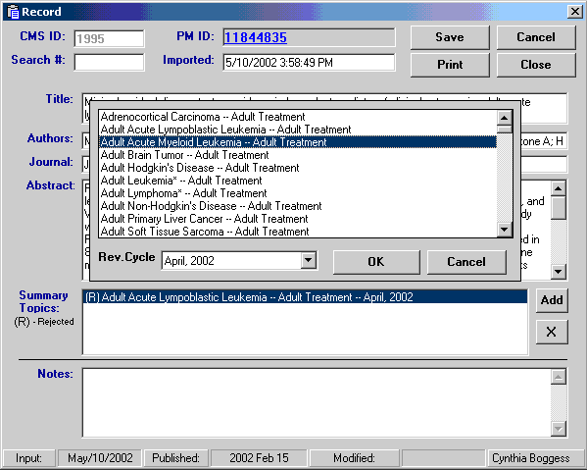

System Help

From the top of any screen, click on “System Help” to open an online version of this documentation. From the CMS Help window, use the table of contents in the left-hand side bar to navigate the documentation. Click on the “+” to expand the table of contents.

